**Joseph Huaynate**

**CUNY ID: 7731  
 Class: CS-331  
 Project # 2**

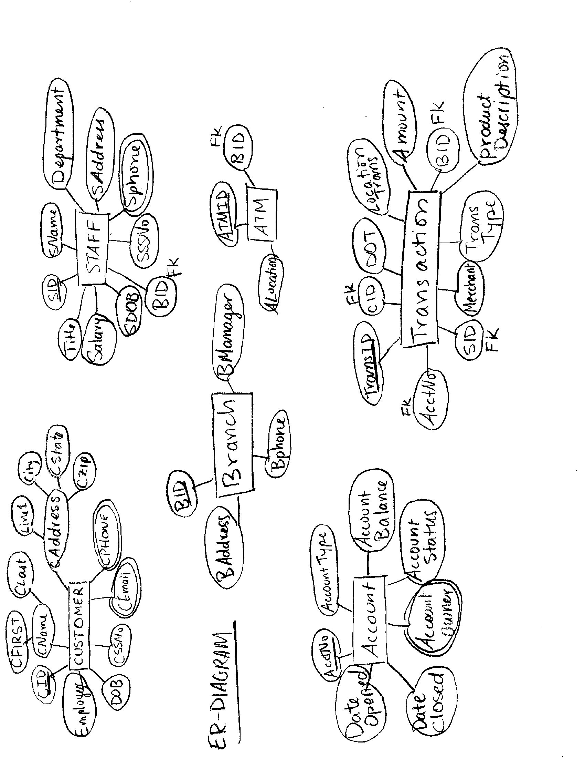

Creation of Customer Table

CREATE TABLE Customer

(CID varchar(5) not NULL,

CFirst varchar(15) not NULL,

CLast varchar(15) not NULL,

CAddress char(30) not NULL,

CSSNO number (9) not NULL,

CDOB date not NULL);

ALTER TABLE Customer

ADD CONSTRAINT Customer_pk PRIMARY KEY(CID);

Creation of Customer_Phone Table

CREATE TABLE Customer_Phone

(CID varchar(5) not NULL,

CPhone varchar(12),

CONSTRAINT CustomerPhone_pk PRIMARY KEY (CPhone));

ALTER TABLE Customer_Phone

ADD FOREIGN KEY(CID)

REFERENCES Customer(CID);

Creation of Customer_Email Table

CREATE TABLE Customer_Email

(CID varchar(5) not NULL,

CEmail varchar(20),

CONSTRAINT CEmail_pk PRIMARY KEY (CEmail));

ALTER TABLE Customer_Email

ADD FOREIGN KEY(CID)

REFERENCES Customer(CID);

1)INSERT into Customer(CID, CFirst, CLast, CAddress, CSSNO, CDOB)

VALUES('0001', 'Joseph', 'Huaynate', '1234 LaLa Land', 123456789 ,'02-08-1993')

2)INSERT into Customer(CID, CFirst, CLast, CAddress, CSSNO, CDOB)

VALUES('0002', 'Roger', 'Jones', '473 Loli St.', 637676227 ,'07-11-1983')

3) INSERT into Customer(CID, CFirst, CLast, CAddress, CSSNO, CDOB)

VALUES('0003', 'Daffy', 'Duck', '334 Looney Ave.', 249697801 ,'04-23-1975')

4) INSERT into Customer(CID, CFirst, CLast, CAddress, CSSNO, CDOB)

VALUES('0004', 'Penny', 'Lincoln', '145 Liberty Dr.', 411560177 ,'01-13-1977')

5) INSERT into Customer(CID, CFirst, CLast, CAddress, CSSNO, CDOB)

VALUES('0005', 'Hugh', 'Mungus', '254 Large Ave.', 794111903 ,'10-07-1988')

6) INSERT into Customer(CID, CFirst, CLast, CAddress, CSSNO, CDOB)

VALUES('0006', 'Von', 'Doom', '004 Fantastic Ave.', 608151253 ,'12-12-1979')

7) INSERT into Customer(CID, CFirst, CLast, CAddress, CSSNO, CDOB)

VALUES('0007', 'Tony', 'Wild', '631 Safari St.', 968459885 ,'05-30-1991')

8) INSERT into Customer(CID, CFirst, CLast, CAddress, CSSNO, CDOB)

VALUES('0008', 'Harry', 'Potter', '777 Magic Ave.', 191069062 ,'03-13-1990')

9) INSERT into Customer(CID, CFirst, CLast, CAddress, CSSNO, CDOB)

VALUES('0009', 'Minnie', 'Driver', '321 Apples Ave.', 624483838 ,'03-24-1975')

10) INSERT into Customer(CID, CFirst, CLast, CAddress, CSSNO, CDOB)

VALUES('0010', 'Betty', 'Thomas', '567 Letters St.', 53147633 ,'12-04-1980')

11) INSERT into Customer(CID, CFirst, CLast, CAddress, CSSNO, CDOB)

VALUES('0011', 'Drake', 'Smith', '25 Discovery Dr.', 140813247 ,'02-24-1983')

12) INSERT into Customer(CID, CFirst, CLast, CAddress, CSSNO, CDOB)

VALUES('0012', 'Vincent', 'Valentine', '0214 Love Dr.', 422271106 ,'02-14-1978')

13) INSERT into Customer(CID, CFirst, CLast, CAddress, CSSNO, CDOB)

VALUES('0013', 'Charlie', 'Brown', '231 Miss St.', 349589960 ,'05-17-1956')

14) INSERT into Customer(CID, CFirst, CLast, CAddress, CSSNO, CDOB)

VALUES('0014', 'James', 'Bond', '007 Royal Ave.', 230281595 ,'11-21-1972')

15) INSERT into Customer(CID, CFirst, CLast, CAddress, CSSNO, CDOB)

VALUES('0015', 'Stephen', 'Hawking', '789 Nutshell St.', 414739929 ,'04-22-1962')

16) INSERT into Customer(CID, CFirst, CLast, CAddress, CSSNO, CDOB)

VALUES('0016', 'Donny', 'Darko', '111 Bandit Ave.', 252744823 ,'06-12-1989')

17) INSERT into Customer(CID, CFirst, CLast, CAddress, CSSNO, CDOB)

VALUES('0017', 'Neo', 'Chosinyuan', '101 Matrix St.', 650484986 ,'08-17-1998')

18) INSERT into Customer(CID, CFirst, CLast, CAddress, CSSNO, CDOB)

VALUES('0018', 'Simba', 'Lyon', '623 Pride Ave.', 171403747 ,'09-23-1993')

19) INSERT into Customer(CID, CFirst, CLast, CAddress, CSSNO, CDOB)

VALUES('0019', 'George', 'Foreman', '385 Grill Dr.', 539842578 ,'11-01-1956')

20) INSERT into Customer(CID, CFirst, CLast, CAddress, CSSNO, CDOB)

VALUES('0020', 'Elvis', 'Presley', '100 Grace Land St.', 212524446 ,'12-15-1943')

Insertion to Customer_Phone Table

INSERT into Customer_Phone(CID, CPhone)

VALUES('0001', '646-123-7654')

INSERT into Customer_Phone(CID, CPhone)

VALUES('0001', '917-234-0987')

INSERT into Customer_Phone(CID, CPhone)

VALUES('0002', '516-235-7458')

INSERT into Customer_Phone(CID, CPhone)

VALUES('0003', '305-145-6238')

INSERT into Customer_Phone(CID, CPhone)

VALUES('0003', '315-089-2618')

INSERT into Customer_Phone(CID, CPhone)

VALUES('0004', '209-617-8375')

INSERT into Customer_Phone(CID, CPhone)

VALUES('0004', '209-743-2647')

INSERT into Customer_Phone(CID, CPhone)

VALUES('0005', '315-728-1947')

INSERT into Customer_Phone(CID, CPhone)

VALUES('0006', '351-637-1284')

INSERT into Customer_Phone(CID, CPhone)

VALUES('0006', '351-233-1777')

INSERT into Customer_Phone(CID, CPhone)

VALUES('0007', '702-675-5766')

INSERT into Customer_Phone(CID, CPhone)

VALUES('0008', '518-564-2134')

INSERT into Customer_Phone(CID, CPhone)

VALUES('0009', '209-243-9647')

INSERT into Customer_Phone(CID, CPhone)

VALUES('0009', '209-564-2199')

INSERT into Customer_Phone(CID, CPhone)

VALUES('0010', '351-675-4235')

INSERT into Customer_Phone(CID, CPhone)

VALUES('0011', '518-756-0098')

INSERT into Customer_Phone(CID, CPhone)

VALUES('0011', '518-456-5634')

INSERT into Customer_Phone(CID, CPhone)

VALUES('0012', '401-326-3748')

INSERT into Customer_Phone(CID, CPhone)

VALUES('0013', '917-364-8475')

INSERT into Customer_Phone(CID, CPhone)

VALUES('0014', '657-345-9876')

INSERT into Customer_Phone(CID, CPhone)

VALUES('0015', '209-654-8790')

INSERT into Customer_Phone(CID, CPhone)

VALUES('0015', '209-657-9821')

INSERT into Customer_Phone(CID, CPhone)

VALUES('0016', '351-765-0465')

INSERT into Customer_Phone(CID, CPhone)

VALUES('0016', '351-456-3645')

INSERT into Customer_Phone(CID, CPhone)

VALUES('0017', '401-436-7561')

INSERT into Customer_Phone(CID, CPhone)

VALUES('0018', '209-748-4876')

INSERT into Customer_Phone(CID, CPhone)

VALUES('0019', '305-667-8970')

INSERT into Customer_Phone(CID, CPhone)

VALUES('0019', '305-342-6643')

INSERT into Customer_Phone(CID, CPhone)

VALUES('0020', '914-235-3470')

Insertion of data to Customer_Email

INSERT into Customer_Email(CID, CEmail)

VALUES('0001', 'jahuay93@gmail.com')

INSERT into Customer_Email(CID, CEmail)

VALUES('0002', 'jonesr@gmail.com')

INSERT into Customer_Email(CID, CEmail)

VALUES('0003', 'rabbitseason@duck.co')

INSERT into Customer_Email(CID, CEmail)

VALUES('0004', 'logs@honest.com')

INSERT into Customer_Email(CID, CEmail)

VALUES('0005', 'smalls@gmail.com')

INSERT into Customer_Email(CID, CEmail)

VALUES('0006', 'notfantastic@evil.co')

INSERT into Customer_Email(CID, CEmail)

VALUES('0007', 'jungle@gmail.com')

INSERT into Customer_Email(CID, CEmail)

VALUES('0008', 'scars@gmail.com')

INSERT into Customer_Email(CID, CEmail)

VALUES('0008', 'wands@gmail.com')

INSERT into Customer_Email(CID, CEmail)

VALUES('0009', 'hunting@gmail.com')

INSERT into Customer_Email(CID, CEmail)

VALUES('0009', 'pointe@gmail.com')

INSERT into Customer_Email(CID, CEmail)

VALUES('0010', 'smithd@gmail.com')

INSERT into Customer_Email(CID, CEmail)

VALUES('0011', 'thomasb@gmail.com')

INSERT into Customer_Email(CID, CEmail)

VALUES('0012', 'vinnie@gmail.com')

INSERT into Customer_Email(CID, CEmail)

VALUES('0013', 'snoopy@gmail.com')

INSERT into Customer_Email(CID, CEmail)

VALUES('0014', 'secret@gmail.com')

INSERT into Customer_Email(CID, CEmail)

VALUES('0014', 'public@gmail.com')

INSERT into Customer_Email(CID, CEmail)

VALUES('0015', 'universe@gmail.com')

INSERT into Customer_Email(CID, CEmail)

VALUES('0016', 'deppj@gmail.com')

INSERT into Customer_Email(CID, CEmail)

VALUES('0017', 'redpill@gmail.com')

INSERT into Customer_Email(CID, CEmail)

VALUES('0017', 'theone@gmail.com')

INSERT into Customer_Email(CID, CEmail)

VALUES('0018', 'matata@gmail.com')

INSERT into Customer_Email(CID, CEmail)

VALUES('0019', 'iwon@gmail.com')

INSERT into Customer_Email(CID, CEmail)

VALUES('0020', 'hounddog@gmail.com')

Creation of Branch Table

CREATE TABLE Branch

(BID varchar(5) not NULL,

BAddress char(30) not NULL,

BPhone varchar (12) not NULL,

BManager varchar(20) not NULL);

ALTER TABLE Branch

ADD CONSTRAINT Branch_pk PRIMARY KEY(BID);

Creation of Branch_Manager Table

CREATE TABLE Branch_Managers(

BID varchar(5) not NULL,

BManager varchar(20) not NULL);

ALTER TABLE Branch_Managers

ADD CONSTRAINT BManagers_pk PRIMARY KEY(BManager);

ALTER TABLE Branch_Managers

ADD FOREIGN KEY(BID)

REFERENCES Branch(BID);

Insertion of data to Branch Table

INSERT into Branch(BID, BAddress, BPhone)

VALUES('1001', ' 192 Main Street', '917-345-2345')

INSERT into Branch(BID, BAddress, BPhone)

VALUES('1002', ' 321 Center Street', '718-657-0984')

INSERT into Branch(BID, BAddress, BPhone)

VALUES('1003', ' 423 Lexington Ave', '718-412-8456')

INSERT into Branch(BID, BAddress, BPhone)

VALUES('1004', ' 100 Madison Ave', '718-657-0567')

INSERT into Branch(BID, BAddress, BPhone)

VALUES('1005', ' 132 Broadway', '718-434-8976')

Insertion of data to Branch_Manager Table

INSERT into Branch_Managers(BID, BManager)

VALUES('1001', 'Ellis Pelvis')

INSERT into Branch_Managers(BID, BManager)

VALUES('1001', 'Toby Liert')

INSERT into Branch_Managers(BID, BManager)

VALUES('1002', 'Nancy Ranell')

INSERT into Branch_Managers(BID, BManager)

VALUES('1002', 'Andy Toys')

INSERT into Branch_Managers(BID, BManager)

VALUES('1003', 'Ray Mantel')

INSERT into Branch_Managers(BID, BManager)

VALUES('1004', 'Thomas Major')

INSERT into Branch_Managers(BID, BManager)

VALUES('1005', 'Tom Riddle')

INSERT into Branch_Managers(BID, BManager)

VALUES('1005', 'Joanne Rowling')

Creation of Staff Table

CREATE TABLE Staff

(SID varchar(5) not NULL,

SName varchar(30) not NULL,

SAddress varchar (20) not NULL,

SPhone varchar(12) not NULL,

SSSNO varchar(12) not NULL,

SDOB date not NULL,

Title varchar(15) not NULL,

Salary number(10) not NULL,

Department varchar(20) not NULL,

BID varchar(5) not NULL);

ALTER TABLE Staff

ADD CONSTRAINT Staff_pk PRIMARY KEY(SID);

Insertion to Staff Table

INSERT into Staff(SID,SName, SAddress, SPhone, SSSNO, SDOB, Title, Salary, Department, BID)

VALUES('2001', 'Veronica Mars', '321 Lane St.', '917-364-8756', '933-06-215','02-03-1990', 'Loan Clerk', '25000', 'Banking', 1001)

INSERT into Staff(SID,SName, SAddress, SPhone, SSSNO, SDOB, Title, Salary, Department, BID)

VALUES('2002', 'Tommy Pickles', '763 Baby Ave.', '917-473-8347', '709-20-1854','11-21-1988', 'Loan Processor', '40000', 'Banking', 1001)

INSERT into Staff(SID,SName, SAddress, SPhone, SSSNO, SDOB, Title, Salary, Department, BID)

VALUES('2003', 'Rick Ranger', '732 West Ave.', '917-723-3746', '353-97-1727','02-12-1979', 'Personal Banker', '45000', 'Banking', 1002)

INSERT into Staff(SID,SName, SAddress, SPhone, SSSNO, SDOB, Title, Salary, Department, BID)

VALUES('2004', 'Tom Wolff', '321 Madison Ave.', '917-564-9465', '662-18-8563','11-30-1982', 'Trust Assistant', '42000', 'Banking', 1002)

INSERT into Staff(SID,SName, SAddress, SPhone, SSSNO, SDOB, Title, Salary, Department, BID)

VALUES('2005', 'Sam Peterson', '451 Lexington Ave.', '917-634-2124', '115-93-2758','10-10-1981', 'Trust Officer', '30000', 'Banking', 1003)

INSERT into Staff(SID,SName, SAddress, SPhone, SSSNO, SDOB, Title, Salary, Department, BID)

VALUES('2006', 'Laura Davis', '125 Harlem Ave.', '917-627-1235', '177-69-274','04-25-1987', 'Sales Director', '50000', 'Sales/Service', 1003)

INSERT into Staff(SID,SName, SAddress, SPhone, SSSNO, SDOB, Title, Salary, Department, BID)

VALUES('2007', 'Ben Lam', '125 86th St.', '917-367-0829', '696-50-4397','08-29-1989', 'Teller', '50000', 'Banking', 1004)

INSERT into Staff(SID,SName, SAddress, SPhone, SSSNO, SDOB, Title, Salary, Department, BID)

VALUES('2008', 'Rachel Baxter', '301 Liberty Ave.', '917-213-0032', '910-66-5513','04-01-1982', 'REO Manager', '70000', 'Banking', 1004)

INSERT into Staff(SID,SName, SAddress, SPhone, SSSNO, SDOB, Title, Salary, Department, BID)

VALUES('2009', 'Larry King', '521 Simpson Ave.', '914-098-3764', '737-38-9501','05-13-1982', 'Personal Banker', '60000', 'Banking', 1005)

INSERT into Staff(SID,SName, SAddress, SPhone, SSSNO, SDOB, Title, Salary, Department, BID)

VALUES('2010', 'Mary Smith', '321 Way St.', '914-214-2934', '323-52-1095','02-22-1990', 'Loan Clerk', '50000', 'Banking', 1005)

Creation of ATM Table

CREATE TABLE ATM

(ATMID varchar(5) not NULL,

ALocation char(30) not NULL,

BID varchar (5) NULL);

ALTER TABLE ATM

ADD CONSTRAINT ATM_pk PRIMARY KEY(ATMID);

ALTER TABLE ATM

ADD FOREIGN KEY(BID)

REFERENCES Branch(BID);

Inserting data into ATM Table

INSERT into ATM(ATMID, ALocation)

VALUES('4001', '213 Broadway St.')

INSERT into ATM(ATMID, ALocation, BID)

VALUES('4002', '192 Main St.', '1001')

INSERT into ATM(ATMID, ALocation)

VALUES('4003', '235 Washington Sq.')

INSERT into ATM(ATMID, ALocation, BID)

VALUES('4004', '321 Center St.', '1002')

INSERT into ATM(ATMID, ALocation)

VALUES('4005', '507 Lloyd St.')

Creation of Account Table

CREATE TABLE Account

(AcctNo varchar(5) not NULL,

Date_Opened date not NULL,

Date_Closed date NULL,

Acct_Status varchar(5) not NULL);

ALTER TABLE Account

ADD CONSTRAINT Account_pk PRIMARY KEY(AcctNo);

Creation of Account_Customer

CREATE TABLE Account_Customer

(AcctNo varchar(5) not NULL,

CID varchar(5) not NULL);

ALTER TABLE Account_Customer

ADD FOREIGN KEY(AcctNo)

REFERENCES Account(AcctNo);

ALTER TABLE Account_Customer

ADD FOREIGN KEY(CID)

REFERENCES Customer(CID);

Creation of Account_Type Table

CREATE TABLE Account_Type

(AcctNo varchar(5) not NULL,

Account_Type varchar(15) not NULL,

Account_Balance number(10) not NULL);

ALTER TABLE Account_Type

ADD FOREIGN KEY(AcctNo)

REFERENCES Account(AcctNo);

Insertion of data to Account Table

INSERT into Account(AcctNo, Date_Opened, Acct_Status)

VALUES('6001', '11/03/2009', 'Open')

INSERT into Account(AcctNo, Date_Opened, Acct_Status)

VALUES('6002', '10/13/2011', 'Open')

INSERT into Account(AcctNo, Date_Opened,Date_Closed, Acct_Status)

VALUES('6003', '10/13/2011','10/20/2015', 'Close')

INSERT into Account(AcctNo, Date_Opened, Acct_Status)

VALUES('6004', '03/24/2010', 'Open')

INSERT into Account(AcctNo, Date_Opened, Acct_Status)

VALUES('6005', '02/10/2008', 'Open')

INSERT into Account(AcctNo, Date_Opened, Acct_Status)

VALUES('6006', '08/10/2012', 'Open')

INSERT into Account(AcctNo, Date_Opened, Acct_Status)

VALUES('6007', '08/10/2012', 'Open')

INSERT into Account(AcctNo, Date_Opened, Acct_Status)

VALUES('6008', '04/25/2007', 'Open')

INSERT into Account(AcctNo, Date_Opened,Date_Closed, Acct_Status)

VALUES('6009', '04/25/2007','03/21/2015', 'Close')

INSERT into Account(AcctNo, Date_Opened,Date_Closed, Acct_Status)

VALUES('6010', '06/10/2011','07/12/2015', 'Close')

INSERT into Account(AcctNo, Date_Opened, Acct_Status)

VALUES('6011', '02/11/2012', 'Open')

INSERT into Account(AcctNo, Date_Opened, Acct_Status)

VALUES('6012', '07/23/2013', 'Open')

INSERT into Account(AcctNo, Date_Opened, Acct_Status)

VALUES('6013', '12/16/2014', 'Open')

INSERT into Account(AcctNo, Date_Opened, Date_Closed, Acct_Status)

VALUES('6014', '12/16/2014','09/02/2015', 'Close')

INSERT into Account(AcctNo, Date_Opened, Acct_Status)

VALUES('6015', '07/12/2013', 'Open')

INSERT into Account(AcctNo, Date_Opened, Acct_Status)

VALUES('6016', '04/03/2014', 'Open')

INSERT into Account(AcctNo, Date_Opened, Acct_Status)

VALUES('6017', '08/05/2015', 'Open')

INSERT into Account(AcctNo, Date_Opened, Acct_Status)

VALUES('6018', '12/11/2009', 'Open')

INSERT into Account(AcctNo, Date_Opened, Date_Closed, Acct_Status)

VALUES('6019', '02/17/2014','02/19/2015', 'Close')

INSERT into Account(AcctNo, Date_Opened, Acct_Status)

VALUES('6020', '01/15/2010', 'Open')

Insertion of data to Account_Customer Table

INSERT into Account_Customer(AcctNo, CID)

VALUES('6001', '0001')

INSERT into Account_Customer(AcctNo, CID)

VALUES('6002', '0002')

INSERT into Account_Customer(AcctNo, CID)

VALUES('6003', '0003')

INSERT into Account_Customer(AcctNo, CID)

VALUES('6004', '0004')

INSERT into Account_Customer(AcctNo, CID)

VALUES('6005', '0005')

INSERT into Account_Customer(AcctNo, CID)

VALUES('6006', '0006')

INSERT into Account_Customer(AcctNo, CID)

VALUES('6007', '0007')

INSERT into Account_Customer(AcctNo, CID)

VALUES('6008', '0008')

INSERT into Account_Customer(AcctNo, CID)

VALUES('6009', '0009')

INSERT into Account_Customer(AcctNo, CID)

VALUES('6010', '0010')

INSERT into Account_Customer(AcctNo, CID)

VALUES('6011', '0011')

INSERT into Account_Customer(AcctNo, CID)

VALUES('6012', '0012')

INSERT into Account_Customer(AcctNo, CID)

VALUES('6013', '0013')

INSERT into Account_Customer(AcctNo, CID)

VALUES('6014', '0014')

INSERT into Account_Customer(AcctNo, CID)

VALUES('6015', '0015')

INSERT into Account_Customer(AcctNo, CID)

VALUES('6016', '0016')

INSERT into Account_Customer(AcctNo, CID)

VALUES('6017', '0017')

INSERT into Account_Customer(AcctNo, CID)

VALUES('6018', '0018')

INSERT into Account_Customer(AcctNo, CID)

VALUES('6019', '0019')

INSERT into Account_Customer(AcctNo, CID)

VALUES('6020', '0020')

Insertion of data to Account_Type Table

INSERT into Account_Type(AcctNo, Account_Type, Account_Balance)

VALUES('6001', 'Checkings', ‘1000’)

INSERT into Account_Type(AcctNo, Account_Type, Account_Balance)

VALUES('6002', 'Savings', ‘600’)

INSERT into Account_Type(AcctNo, Account_Type, Account_Balance)

VALUES('6003', 'Debit Card', ’0’)

INSERT into Account_Type(AcctNo, Account_Type, Account_Balance)

VALUES('6004', 'Credit Card', ‘2500’)

INSERT into Account_Type(AcctNo, Account_Type, Account_Balance)

VALUES('6005', 'Credit Card', ‘300’)

INSERT into Account_Type(AcctNo, Account_Type, Account_Balance)

VALUES('6006', 'Credit Card', ‘700’)

INSERT into Account_Type(AcctNo, Account_Type, Account_Balance)

VALUES('6007', 'Checkings', ‘700’)

INSERT into Account_Type(AcctNo, Account_Type, Account_Balance)

VALUES('6008', 'Savings', ‘2000’)

INSERT into Account_Type(AcctNo, Account_Type, Account_Balance)

VALUES('6009', 'Debit Card', ‘0’)

INSERT into Account_Type(AcctNo, Account_Type, Account_Balance)

VALUES('6010', 'Savings', ‘0’)

INSERT into Account_Type(AcctNo, Account_Type, Account_Balance)

VALUES('6011', 'Credit Card', ‘600’)

INSERT into Account_Type(AcctNo, Account_Type, Account_Balance)

VALUES('6012', 'Savings', ‘300’)

INSERT into Account_Type(AcctNo, Account_Type, Account_Balance)

VALUES('6013', 'Savings', ‘800’)

INSERT into Account_Type(AcctNo, Account_Type, Account_Balance)

VALUES('6014', 'Checkings', ‘0’)

INSERT into Account_Type(AcctNo, Account_Type, Account_Balance)

VALUES('6015', 'Checkings', '900')

INSERT into Account_Type(AcctNo, Account_Type, Account_Balance)

VALUES('6015', 'Savings', '700')

INSERT into Account_Type(AcctNo, Account_Type, Account_Balance)

VALUES('6016', 'Credit Card', '900')

INSERT into Account_Type(AcctNo, Account_Type, Account_Balance)

VALUES('6017', 'Savings', '200')

INSERT into Account_Type(AcctNo, Account_Type, Account_Balance)

VALUES('6018', 'Debit Card', '400')

INSERT into Account_Type(AcctNo, Account_Type, Account_Balance)

VALUES('6019', 'Debit Card', '0')

INSERT into Account_Type(AcctNo, Account_Type, Account_Balance)

VALUES('6020', 'Credit Card', '3000')

Creation of Transaction Table

CREATE TABLE Transaction

(TransID varchar(5) not NULL,

CID varchar(5) not NULL,

AcctNo varchar(5) not NULL,

BID varchar(5) NULL,

SID varchar (5) NULL,

ATMID varchar(5) NULL,

Location_Purchase varchar(30) NULL,

DOT date not NULL,

Amount number(10) not NULL,

Merchant varchar(20) NULL,

Product_Descrpt varchar(50) NULL,

Trans_Type varchar(10) not NULL);

Insertion to Transaction Table

INSERT into Transaction(TransID, CID, AcctNo, BID, SID, DOT, Amount, Trans_Type)

VALUES('8001','0001', '6001', '1001', '2007', '10-25-2016', '-100', 'Withdrawal')

INSERT into Transaction(TransID, CID, AcctNo, BID, SID, DOT, Amount, Trans_Type)

VALUES('8002','0001', '6001', '1001', '2007', '02-15-2016', '200', 'Deposit')

INSERT into Transaction(TransID, CID, AcctNo, Location_Purchase, DOT, Amount, Merchant, Product_Descrpt, Trans_Type)

VALUES('8003','0001', '6001','231 Lexington Ave.' ,'04-21-2016', '20','Burger King', '5 burgers ','Purchase')

INSERT into Transaction(TransID, CID, AcctNo, Location_Purchase, DOT, Amount, Merchant, Product_Descrpt, Trans_Type)

VALUES('8004','0001', '6001','132 Madison Ave.' ,'07-11-2016', '5','Babies"R"Us', 'A baby rattle ','Return')

INSERT into Transaction(TransID, CID, AcctNo, BID, SID, DOT, Amount, Trans_Type)

VALUES('8005','0001', '6001', '1004', '2007', '05-20-2016', '400', 'Deposit')

INSERT into Transaction(TransID, CID, AcctNo, BID, SID, DOT, Amount, Trans_Type)

VALUES('8007','0002', '6002', '1004', '2007', '09-15-2015', '-80', 'Withdrawal')

INSERT into Transaction(TransID, CID, AcctNo, Location_Purchase, DOT, Amount, Merchant, Product_Descrpt, Trans_Type)

VALUES('8008','0002', '6002','612 Broadway Ave.' ,'01-07-2016', '3','StarBucks', 'Medium Coffee ','Purchase')

INSERT into Transaction(TransID, CID, AcctNo, BID, SID, DOT, Amount, Trans_Type)

VALUES('8009','0002', '6002', '1004', '2007', '10-05-2016', '-200', 'Withdrawal')

INSERT into Transaction(TransID, CID, AcctNo, Location_Purchase, DOT, Amount, Merchant, Product_Descrpt, Trans_Type)

VALUES('8010','0002', '6002','231 87th St.' ,'08-04-2016', '50','GAP', 'Pair of Jeans ','Purchase')

INSERT into Transaction(TransID, CID, AcctNo, Location_Purchase, DOT, Amount, Merchant, Product_Descrpt, Trans_Type)

VALUES('8011','0004', '6004','107 Madison Ave.' ,'09-24-2016', '100','Antique Store', 'Collection of Old Pennies','Purchase')

INSERT into Transaction(TransID, CID, AcctNo, Location_Purchase, DOT, Amount, Merchant, Product_Descrpt, Trans_Type)

VALUES('8013','0004', '6004','213 42 St.' ,'03-21-2016', '10','Baby GAP', 'A Shirt','Purchase')

INSERT into Transaction(TransID, CID, AcctNo, BID, SID, DOT, Amount, Trans_Type)

VALUES('8015','0004', '6004', '1004', '2007', '11-05-2016', '150', 'Deposit')

INSERT into Transaction(TransID, CID, AcctNo, BID, SID, DOT, Amount, Trans_Type)

VALUES('8018','0005', '6005', '1004', '2007', '11-03-2016', '550', 'Deposit')

INSERT into Transaction(TransID, CID, AcctNo, BID, SID, DOT, Amount, Trans_Type)

VALUES('8022','0005', '6005', '1004', '2007', '11-10-2016', '-300', 'Withdrawal')

INSERT into Transaction(TransID, CID, AcctNo, Location_Purchase, DOT, Amount, Merchant, Product_Descrpt, Trans_Type)

VALUES('8023','0005', '6005','304 Apple St.' ,'07-01-2016', '50','Babies"R"Us', 'Diapers and Baby Formula ','Purchase')

INSERT into Transaction(TransID, CID, AcctNo, Location_Purchase, DOT, Amount, Merchant, Product_Descrpt, Trans_Type)

VALUES('8024','0006', '6006','234 Evil Ave.' ,'05-02-2016', '70','Evil Corp.', 'How To Be Evil Kit','Purchase')

INSERT into Transaction(TransID, CID, AcctNo, Location_Purchase, DOT, Amount, Merchant, Product_Descrpt, Trans_Type)

VALUES('8032','0007', '6007','345 Lovoa Ave.' ,'11-16-2016', '30','Safari Co.', 'Bug Spray and Net ','Purchase')

INSERT into Transaction(TransID, CID, AcctNo, BID, SID, DOT, Amount, Trans_Type)

VALUES('8056','0013', '6013', '1004', '2007', '05-27-2016', '150', 'Deposit')

INSERT into Transaction(TransID, CID, AcctNo, BID, SID, DOT, Amount, Trans_Type)

VALUES('8057','0015', '6015', '1004', '2007', '03-25-2016', '-100', 'Withdrawal')

INSERT into Transaction(TransID, CID, AcctNo, BID, SID, DOT, Amount, Trans_Type)

VALUES('8058','0015', '6015', '1004', '2007', '02-05-2016', '250', 'Deposit')

INSERT into Transaction(TransID, CID, AcctNo, Location_Purchase, DOT, Amount, Merchant, Product_Descrpt, Trans_Type)

VALUES('8059','0015', '6015','123 Lexington Ave.' ,'12-21-2015', '30','Barnes & Noble', '3 books ','Purchase')

INSERT into Transaction(TransID, CID, AcctNo, Location_Purchase, DOT, Amount, Merchant, Product_Descrpt, Trans_Type)

VALUES('8060','0016', '6016','708 Lexington Ave.' ,'03-21-2016', '300','Secrets Inc.', 'Weapons','Purchase')

INSERT into Transaction(TransID, CID, AcctNo, Location_Purchase, DOT, Amount, Merchant, Product_Descrpt, Trans_Type)

VALUES('8061','0016', '6016','708 Lexington Ave.' ,'03-22-2016', '200','Secret Inc.', 'More Weapons','Purchase')

INSERT into Transaction(TransID, CID, AcctNo, BID, SID, DOT, Amount, Trans_Type)

VALUES('8062','0016', '6016', '1004', '2007', '02-28-2016', '750', 'Deposit')

INSERT into Transaction(TransID, CID, AcctNo, BID, SID, DOT, Amount, Trans_Type)

VALUES('8063','0016', '6016', '1004', '2007', '03-25-2016', '-300', 'Withdrawal')

INSERT into Transaction(TransID, CID, AcctNo, BID, SID, DOT, Amount, Trans_Type)

VALUES('8064','0017', '6017', '1004', '2007', '10-08-2016', '150', 'Deposit')

INSERT into Transaction(TransID, CID, AcctNo, BID, SID, DOT, Amount, Trans_Type)

VALUES('8065','0017', '6017', '1004', '2007', '10-09-2016', '250', 'Deposit')

INSERT into Transaction(TransID, CID, AcctNo, BID, SID, DOT, Amount, Trans_Type)

VALUES('8066','0017', '6017', '1004', '2007', '04-07-2016', '-100', 'Withdrawal')

INSERT into Transaction(TransID, CID, AcctNo, Location_Purchase, DOT, Amount, Merchant, Product_Descrpt, Trans_Type)

VALUES('8067','0017', '6017','243 Royal Ave.' ,'08-20-2016', '50','Museum Of Wild Life', '3 posters','Purchase')

INSERT into Transaction(TransID, CID, AcctNo, BID, SID, DOT, Amount, Trans_Type)

VALUES('8068','0018', '6017', '1004', '2007', '03-25-2016', '-300', 'Withdrawal')

INSERT into Transaction(TransID, CID, AcctNo, BID, SID, DOT, Amount, Trans_Type)

VALUES('8069','0018', '6018', '1004', '2007', '02-28-2016', '750', 'Deposit')

INSERT into Transaction(TransID, CID, AcctNo, BID, SID, DOT, Amount, Trans_Type)

VALUES('8070','0018', '6018', '1004', '2007', '04-03-2016', '250', 'Deposit')

INSERT into Transaction(TransID, CID, AcctNo, Location_Purchase, DOT, Amount, Merchant, Product_Descrpt, Trans_Type)

VALUES('8071','0018', '6018','231 Lexington Ave.' ,'03-10-2016', '10','Burger King', 'Whopper Meal ','Purchase')

INSERT into Transaction(TransID, CID, AcctNo, BID, SID, DOT, Amount, Trans_Type)

VALUES('8072','0020', '6020', '1004', '2007', '08-28-2016', '150', 'Deposit')

INSERT into Transaction(TransID, CID, AcctNo, BID, SID, DOT, Amount, Trans_Type)

VALUES('8073','0020', '6020', '1004', '2007', '09-03-2016', '750', 'Deposit')

INSERT into Transaction(TransID, CID, AcctNo, BID, SID, DOT, Amount, Trans_Type)

VALUES('8075','0020', '6020', '1004', '2007', '10-25-2016', '-100', 'Withdrawal')

INSERT into Transaction(TransID, CID, AcctNo, Location_Purchase, DOT, Amount, Merchant, Product_Descrpt, Trans_Type)

VALUES('8076','0020', '6020','231 Lexington Ave.' ,'09-21-2016', '20','Burger King', '5 burgers ','Purchase')

QUESTIONS

1. Identify all credit card accounts with at least 3 transaction in the last 6 months. Display the customer name, address and account balance. Use a nested selected to answer the question.

SELECT Account_Balance, CFirst, CLast, Account_Type, Account.AcctNo, CAddress, DOT

FROM Customer, Account, Account_Customer, Account_Type, Transaction

WHERE Account.AcctNo = Account_Customer.AcctNo

AND Transaction.AcctNo = Account.AcctNo

AND Transaction.DOT > '05-01-2016'

AND Transaction.DOT <'11-16-2016'

AND Account_Customer.CID = Customer.CID

AND Account_Type.AcctNo = Account.AcctNo

AND Account_Type IN ( SELECT Account_Type

FROM Account_Type

WHERE Account_Type = 'Credit Card')

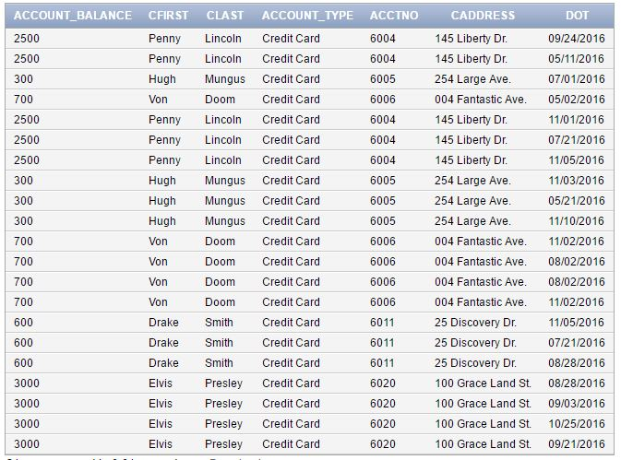

1. Identify all transactions for customer Penny Lincoln last month. Display the transaction date, location, amount number and account type.

SELECT Transaction.DOT "Date Of Transaction", Transaction.Location_Purchase "Location Of Purchase", Transaction.BID , '$' || TO_CHAR(Transaction.Amount) "Amount", Transaction.AcctNo "Account Number", Account_Type.Account_Type "Account Type"

FROM Transaction, Account_Type, Account

WHERE Account_Type.AcctNo = Account.AcctNo

AND Account.AcctNo = Transaction.AcctNo

AND Transaction.CID = '0004'

AND DOT > '10-01-2016'

AND DOT < '11-16-2016'; 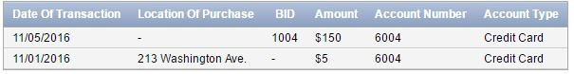

1. Identify number of transaction and total amount of transactions for all customers today. Display the four columns: customer name, number of transaction and total transaction. Display one row for each customer.

SELECT CFirst "First Name", CLast "Last Name", COUNT(DOT) "Total Transactions", SUM(Amount) "Total Amount" FROM Transaction, Customer

WHERE Transaction.CID = Customer.CID

AND Transaction.DOT = '11-16-2016'

GROUP BY CFirst, CLast;



1. The bank is performing an audit of bank teller Ben Lam. Identify all transactions Ben Lam performed last month. Display the employee name, transaction date, location, amount, and account number.

SELECT Staff.SName "Staff Name", Staff.Title "Staff Title", Transaction.DOT "Date Of Transaction", Branch.BAddress "Branch Address",'$' ||TO_CHAR(Transaction.Amount) "Transaction Amount" ,Transaction.AcctNo FROM Staff, Transaction, Branch

WHERE Staff.SID = '2007'

AND Transaction.SID= Staff.SID

AND Transaction.BID = Branch.BID

AND Transaction.DOT > '10-01-2016';

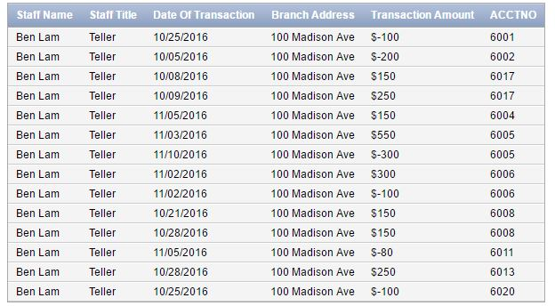

1. Identify all checking accounts that were closed last year. Display the customer name, account number, open and close date.

SELECT Customer.CFirst "First Name", Customer.CLast "Last Name", Account.AcctNo "Account Number",Account.Date_Opened "Date Account Opened", Account.Date_Closed "Date Account Closed" FROM Account, Account_Type,Account_Customer, Customer

WHERE Account.AcctNo = Account_Customer.AcctNo

AND Customer.CID = Account_Customer.CID

AND Account_Type.AcctNo = Account.AcctNo

AND Account_Type.Account_Type = 'Debit Card'

AND Acct_Status = 'Close'

AND Date_Closed > '01-01-2015'

AND Date_Closed < '12-31-2015';

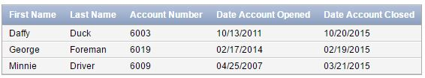

1. Identify the banks top ten customers. Display the customer name, account number, balance, and account type. Display the best customer first and the 10th best last.

SELECT Customer.CFirst "First Name", Customer.CLast "Last Name", Transaction.Trans_Type, SUM(Transaction.Amount) FROM Transaction, Customer

WHERE Transaction.CID = Customer.CID

AND Transaction.Trans_Type = 'Deposit'

GROUP BY Customer.CFirst, Customer.CLast, Transaction.Trans_Type

HAVING SUM(Transaction.Amount) > 450

ORDER BY SUM(Transaction.Amount) DESC;

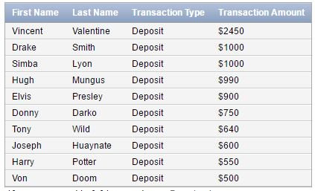

1. Identify customers with no activity in the last six months. Display the customer name.

Use a nested select to answer this question.

SELECT CFirst "First Name", CLast "Last Name" FROM Customer

WHERE CID IN (SELECT CID FROM Transaction

WHERE Transaction.DOT <'05-31-2016')

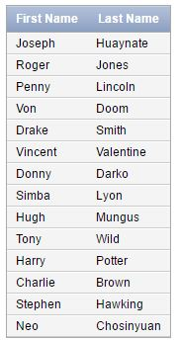

1. Identify customers with no activity in the last six months. Display the customer name and account number.

Use a nested select to answer this question.

SELECT Customer.CFirst "First Name", Customer.CLast "Last Name", Account.AcctNo “Account Number” FROM Customer, Account, Account_Customer

WHERE Account.AcctNo = Account_Customer.AcctNo

AND Account_Customer.CID = Customer.CID

AND Customer.CID IN (SELECT CID FROM Transaction

WHERE Transaction.DOT <'05-31-2016')

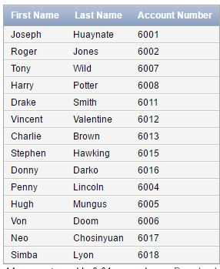

1. Calculate and deposit 1% interest for all active savings account with a balance greater than $500.

UPDATE Account_Type

SET Account_Balance = (Account_Balance * .01) + Account_Balance

WHERE Account_Type = 'Savings'

BEFORE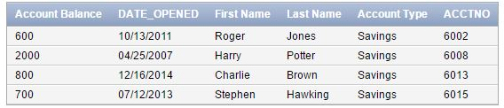

AFTER

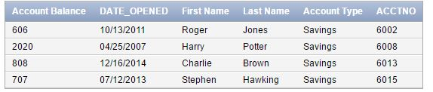

1. Identify customers who purchased baby related products in the last year. Display the customers name, merchant, purchase amount and purchase date.

SELECT Customer.CFirst "First Name", Customer.CLast "Last Name", Transaction.Merchant "Merchant", '$'|| TO_CHAR(Transaction.Amount) "Amount", Transaction.DOT "Date of Transaction" FROM Transaction, Customer

WHERE Transaction.CID = Customer.CID

AND Transaction.Merchant LIKE 'Bab%';

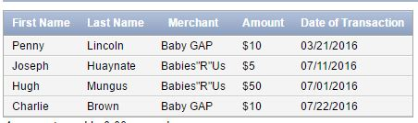

1. Identify transactions by year and month for all locations. Display four columns: Year, month, number of transactions and total sales. Display the year and month with the greatest dollar amount first. Output one row for each year and month.

SELECT TO_CHAR(DOT,'YYYY') "Year", TO_CHAR(DOT,'MM') "Month", COUNT(TransID) "Total Number of Transactions", SUM(Amount) "Total Amount" FROM Transaction

GROUP BY TO_CHAR(DOT,'YYYY'), TO_CHAR(DOT,'MM')

ORDER BY SUM(Amount) DESC;

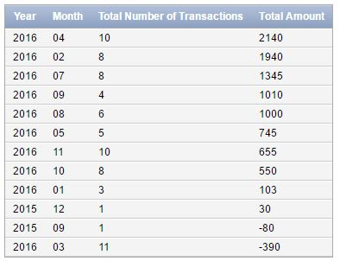

1. Transfer $100 from the savings account to the checking account for one customer. Identify the SQL operations to perform this operation.

UPDATE Account_Type

SET Account_Balance = Account_Balance -100

WHERE Account_Type = 'Savings'

AND AcctNo = '6015'

$100 less from Savings

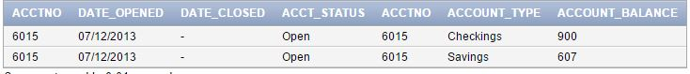

UPDATE Account_Type

SET Account_Balance = Account_Balance + 100

WHERE Account_Type = 'Checkings'

AND AcctNo = '6015'

$100 more in Checkings

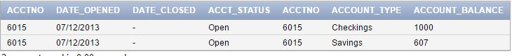

1. A customer wants to remove all money and close all their accounts at the bank. Identify the most efficient SQL operations to perform this operation.

I want to close my account. My account number is 6001. Here is a pic before my exit.



Now I want to clear out my balance.

UPDATE Account_Type

SET Account_Balance = 0

WHERE AcctNo = '6001';



Now I want to Close my account.

UPDATE Account

SET Acct_Status = 'Close'

WHERE AcctNo = '6001';



1. Display the table structure using SQSL Describe operation.

DESCRIBE Customer;

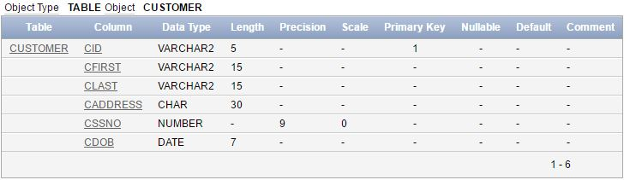

DESCRIBE Customer_Email;

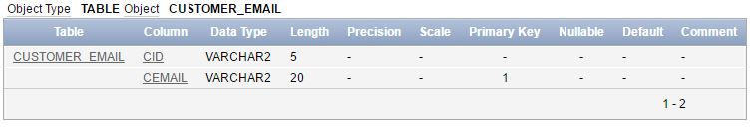

DESCRIBE Customer_Phone;

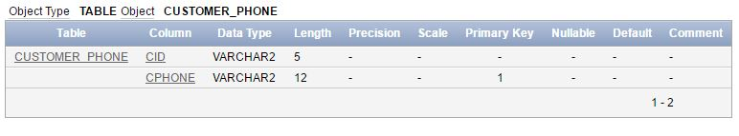

DESCRIBE Account;

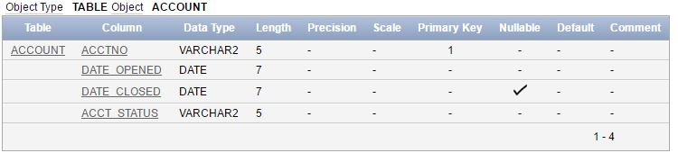

DESCRIBE Account_Customer;

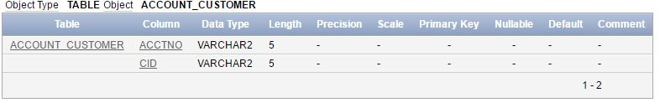

DESCRIBE Account_Type;

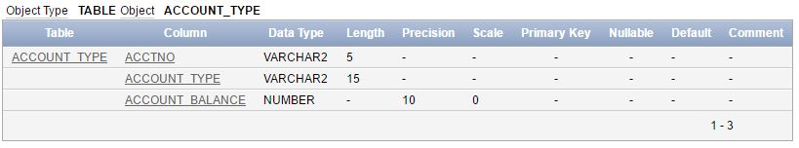

DESCRIBE Staff;

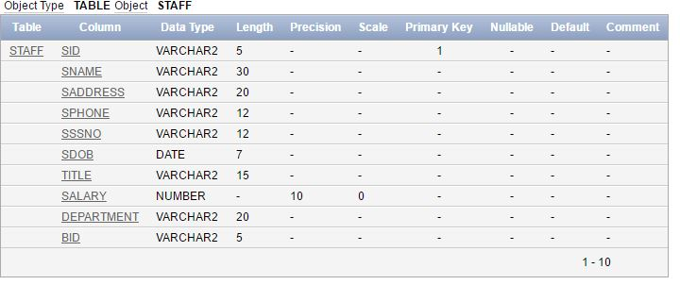

DESCRIBE Branch;

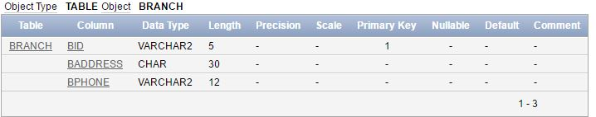

DESCRIBE ATM;

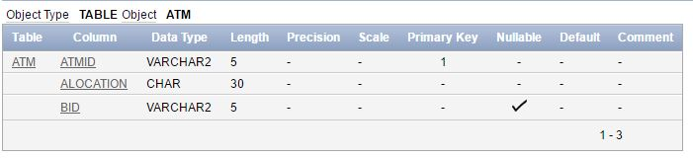

DESCRIBE Transaction;

